Project Development Phase
User Acceptance Testing (UAT) Plan & Execution
Project Overview & Environment:
Project Name: Auto Ticket Classification using Flow Designer | Version: 1.0 | Testing Period: 20 Sep 2026 - 02 Oct 2026
Environment: ServiceNow Developer Instance (PDI - Global Scope) | Roles: System Administrator & ITIL
Test Cases Execution Matrix:
Test Case ID | Feature / Requirement | Precondition | Test Steps | Expected Result | Status
TC-01 | Update Set Tracking | Admin logged in | Create 'Project Update Set', make Current | Set appears as Current in header | Pass
TC-02 | Custom Table & Numbering | Admin logged in | Create table 'Incident WorkFlow', check Auto Number | Table created; numbers prefix INC | Pass
TC-03 | Field Creation & Layout | Form Designer open | Add Caller, Short Description, State, Category, Subcategory | Fields visible on form in correct order | Pass
TC-04 | Dependent Choices | Subcategory dictionary | Configure 'Use dependent field = category' | Subcategories filter by Category | Pass
TC-05 | Flow Trigger Activation | Flow Designer open | Configure trigger: Table = Incident Workflow, Category is empty | Flow triggers upon record insert | Pass
TC-06 | Keyword Classification | Flow active | Submit tickets with Wi-Fi, Projector, Password, Slow | Correct Category & Subcategory saved | Pass
TC-07 | Email Dispatch | System Logs active | Check sys_email table after classification | Email found with dynamic ticket pills | Pass
TC-08 | Update Set XML Export | Set completed | Change state to Complete, click Export to XML | Valid XML payload downloaded | Pass
Visual Execution Evidence:
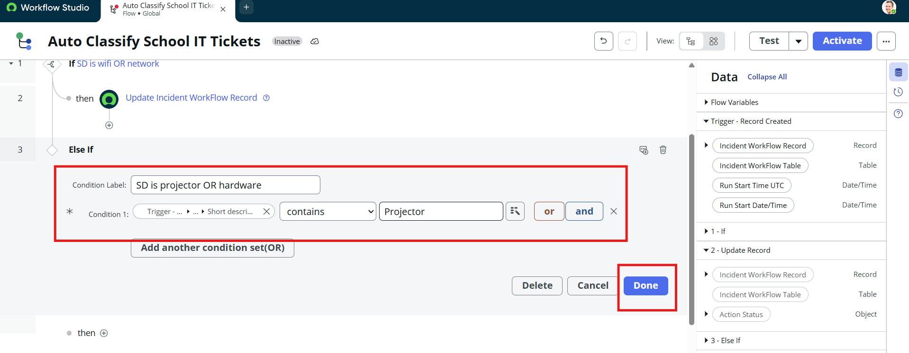
Figure 5.1: UAT Execution Evidence - Record INC00511 Auto-Classified as Network / Wi-Fi
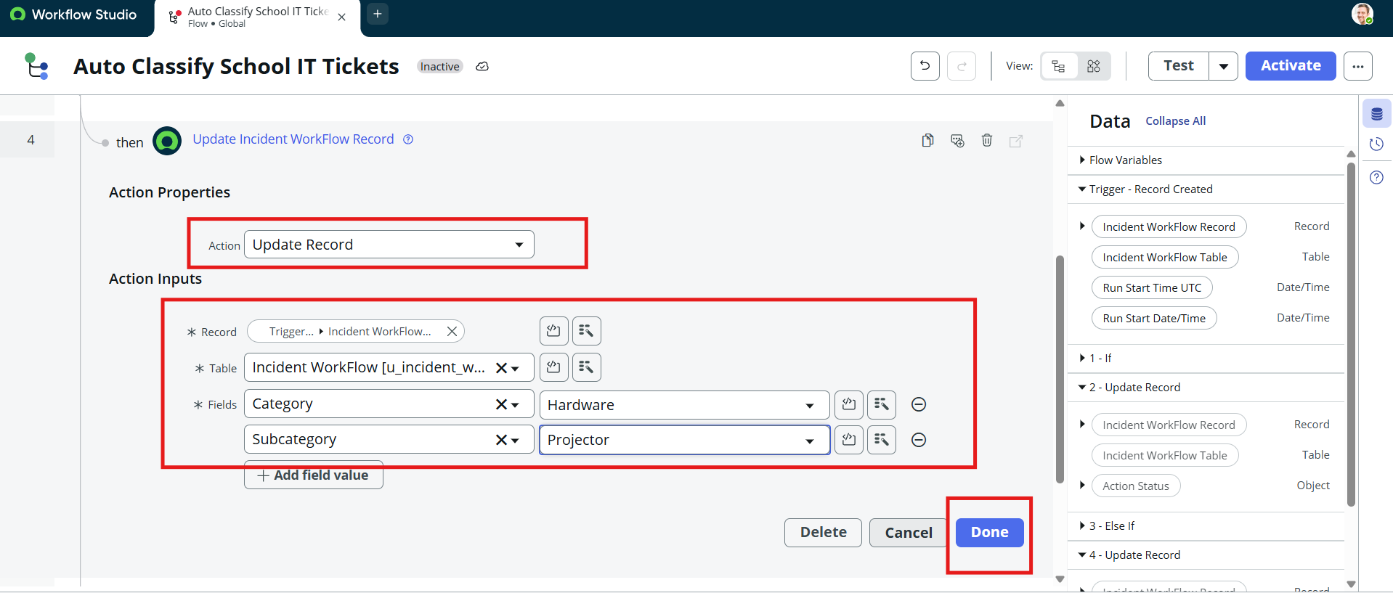
Figure 5.2: UAT Execution Evidence - Record INC00512 Auto-Classified as Hardware / Projector
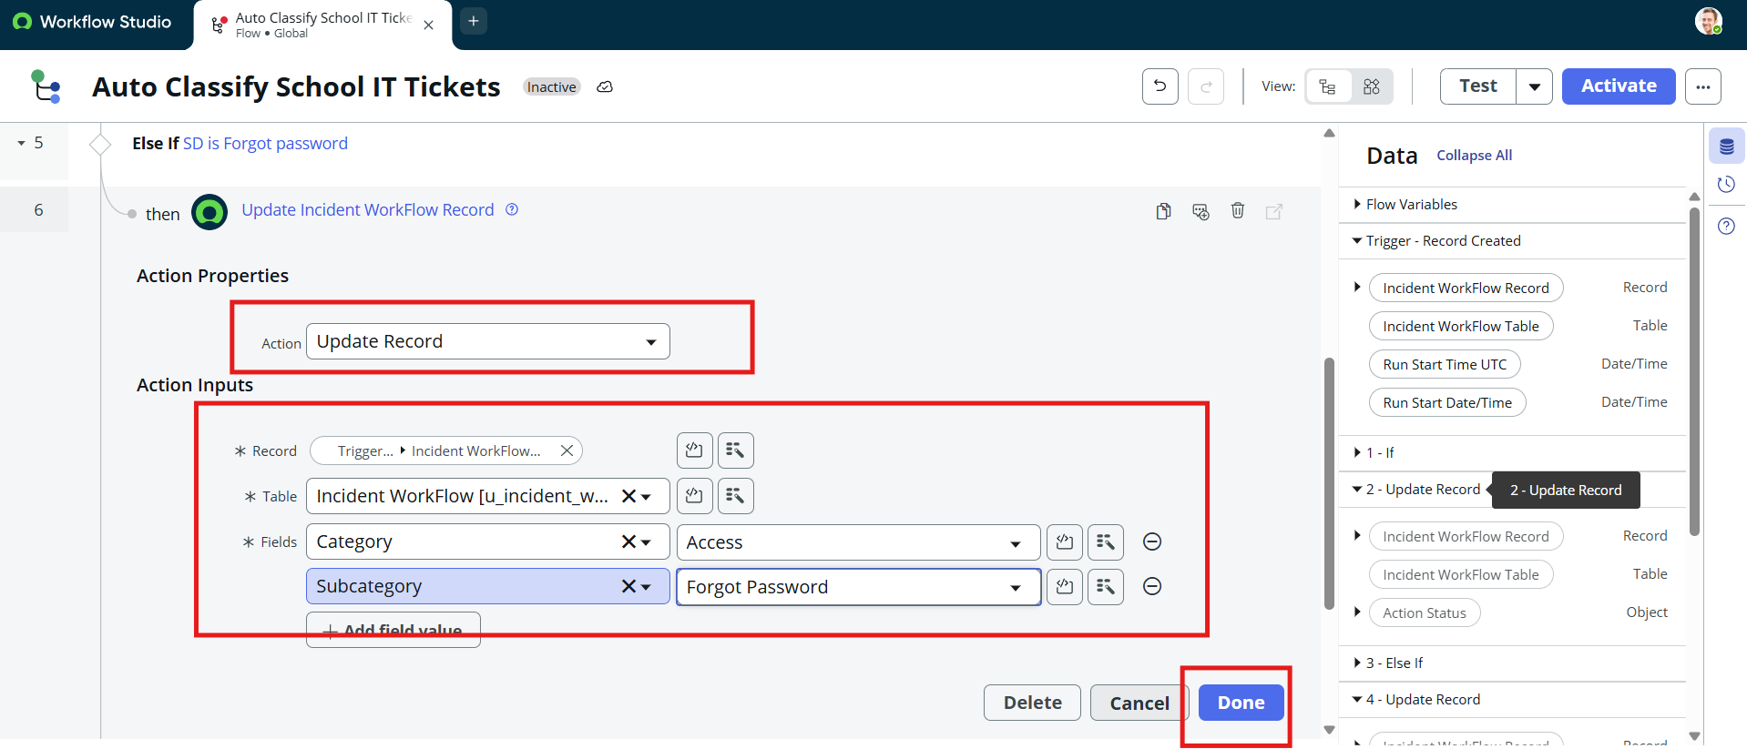
Figure 5.3: Automated Email Notification Log in System Logs > Emails & Preview Mail
Sign-off & Acceptance Approval:
Tester Name: ServiceNow Quality Assurance Lead | Date: 02 October 2026 | Status: PASSED & APPROVED

